Introduction

Dow Benelux B.V. and HZ University of Applied Science work on a case demo of a pilot for a Creek Ridge Infiltration (CRI) system in the area of the Braakman South region near the city of Terneuzen. The outcome of this pilot will result in the development of full-scale business cases for fresh water provisions through alternative resources for both industrial and agricultural end-users. The study is part of a larger FRESH4Cs Interreg program and consists of a technical and non-technical evaluation. The non-technical study will examine the selected solutions and locations for required permits, social and policy barriers and ownership. Infrastructural needs to transport the water to the selected location, and from the location to the end users, is also part of the non-technical study.

Deltares is part of the technical evaluation of potential locations and design of the CRI pilot. The technical study will select areas suitable for underground fresh water storage based on existing and new info. An existing study combines electromagnetic measurements (FRESHEM, determining the salt/fresh water interface) and soil/groundwater characteristics to define areas suitable for infiltration and subsequent abstraction without negatively affecting the surrounding area.

In this memo we will present the findings of the technical evaluation of two locations (see Figure 1) for a Creek Ridge Infiltration (CRI) pilot in the Braakman South area. From the technical evaluation one location will be presented as the location for the actual Creek ridge infiltration pilot. The two locations have been selected based on their high potential for a successful Creek Ridge Infiltration system (see memo phase 1 for detailed information on potential locations in the Braakman South area).

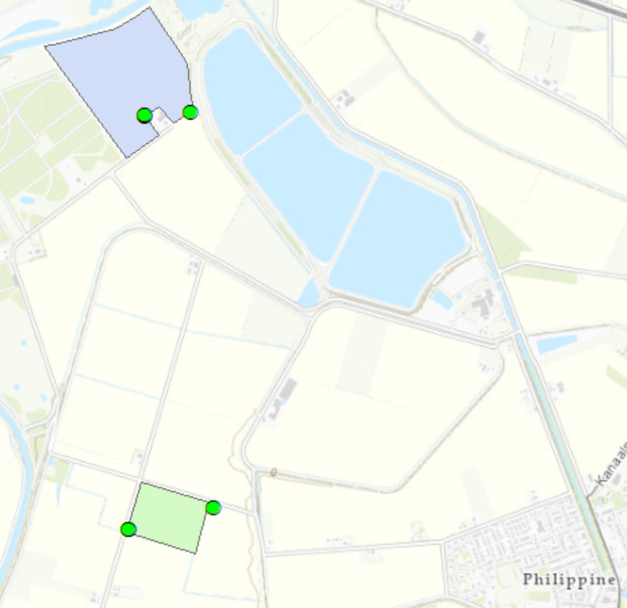
Figure 1 Two locations where field measurements have been conducted. In the North the parcel of dhr. Cruijningen in the South the parcel of dhr. Dieleman. Field measurement locations at the green points.

Field Measurements

In order to choose a final location for a Creek Ridge Infiltration pilot, field measurements have been carried out to validate if, the composition of the subsurface (GeoTOP dataset), the groundwater heads (groundwater model Braakman South, Mulder 2020) and the chloride distribution of the subsurface (FRESHEM dataset) at the locations match. The national and regional datasets gave a first order impression of the feasibility of a CRI pilot as discussed in memo from phase 1.

Field measurements have been carries out at 4 different locations (See Figure 2 &Figure 3 ). A deep and shallow monitoring well was installed as described in Table 1. Telemetric divers were installed in all monitoring wells, the bore logs have been described and a SLIMFLEX measurement was carried out to determine how thick the freshwater lens is at each location. All measurements are described in the following sections of chapter 2.

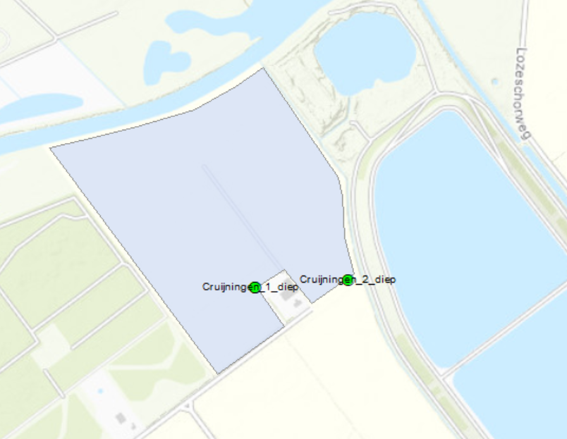
Figure 2 Detailed location of field measurements Cruijningen

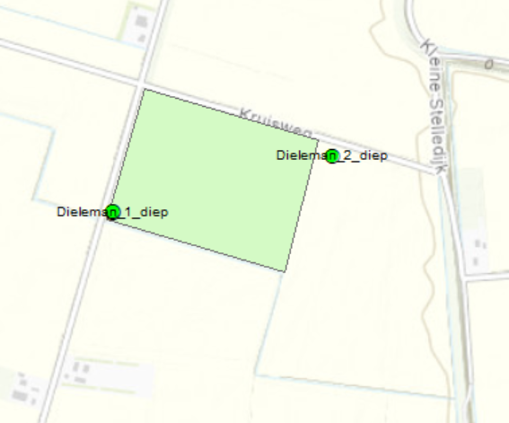
Figure 3 Detailed location field measurements Dieleman

Table 1 Information per Measurement location & expected fresh water lens thickness (FRESHEM)
Name | X | Y | Depth  (m-mv) | Filterlengte (m) | Expected thickness fresh lens (FRESHEM)  (m-mv)
Dieleman_1_diep | 39135 | 367470 | 25 | 1 | 16.5
Dieleman_1_ondiep | 39135 | 367471 | 5 | 1 | 16.5
Dieleman_2_diep | 39565 | 367580 | 25 | 1 | 17
Cruijningen_1_diep | 39215 | 369580 | 25 | 1 | 18
Cruijningen_1_ondiep | 39215 | 369581 | 5 | 1 | 18
Cruijningen_2_diep | 39450 | 369600 | 15 | 1 | 8

Lithology

A creek ridge infiltration pilot should off course be carried out in a sandy creek ridge. In phase 1, the evaluation was carried out where and if a creek ridge existed in the Braakman South region. Both the locations of Cruijningen and Dieleman are situated on a sandy creek ridge. However, the soil composition of a sandy creek ridge can still vary significantly.
The low hydraulic conductivity of clay and peat layers reduce the amount of water that can be infiltrated over a certain amount of time.
The bore log description at the locations of the monitoring wells give a detailed image of the composition of the subsurface. Figure 4 shows the bore log description of the deep wells for “Cruijningen1” and “Cruijningen2”. Figure 5 shows the bore log description of the deep wells for “Dieleman1” and “Dieleman2”. The bore logs are also included in “OP210039 Boorprofielen.pdf”.
A thick and homogenous sandy subsurface is present at locations “Cruijningen1”, “Cruijningen2” and “Dieleman2”. The bore log description of “Dieleman1” shows a sandy subsurface with more organic material than the other bore logs.
Based on the bore log description a CRI system can be implemented in all 4 locations.
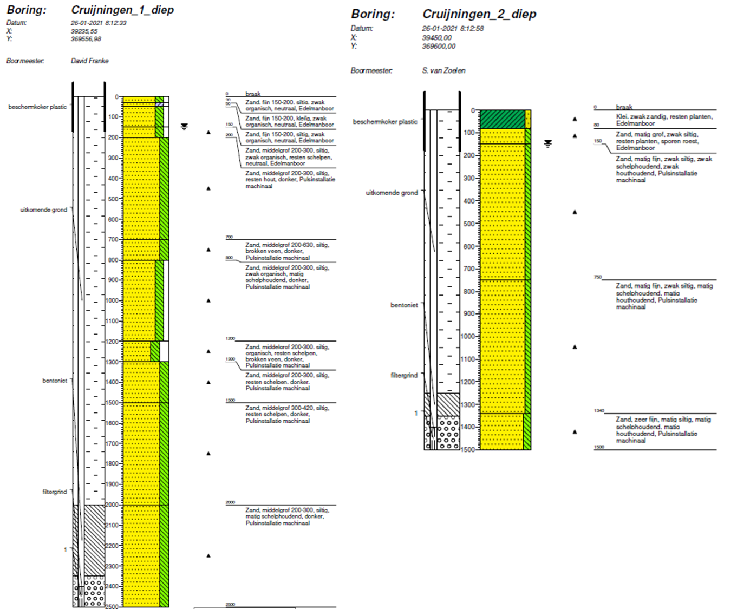
Figure 4 Bore log description for locations at Cruijningen

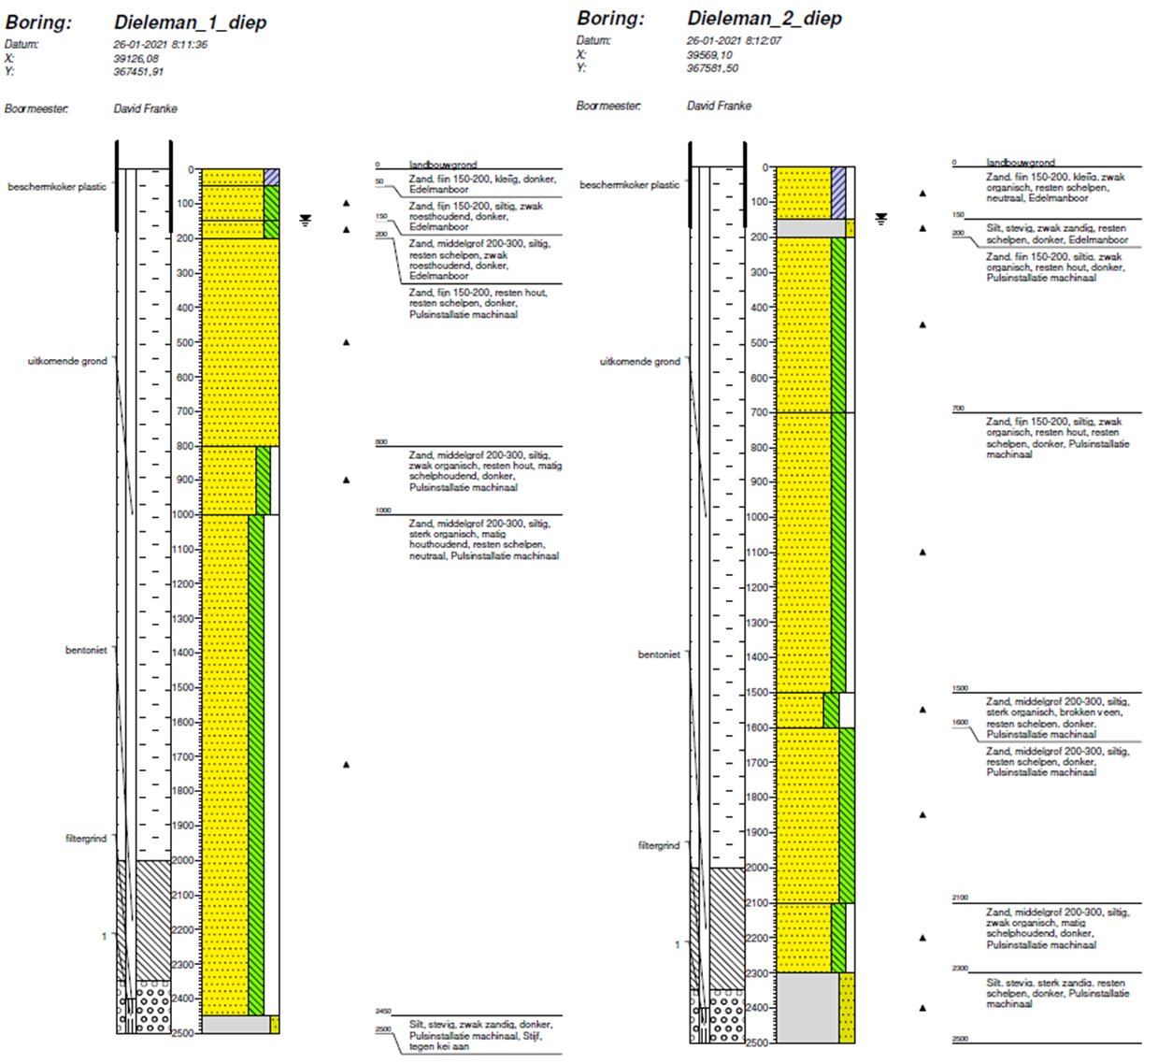
Figure 5 Bore log description for locations at Dieleman

Groundwater heads

TAUW measures the groundwater heads at all locations in table 1. The measurements from March 2021 till August 2021 are shown in Figure 5 - 6. The interaction between deep and shallow groundwater heads is an important aspect in the feasibility study for a CRI system.
If the shallow groundwater heads are lower than the deep groundwater heads, a seepage flux towards the subsurface will most likely occur. This means that water will not infiltrate towards the deeper system and a CRI system is not feasible. If the deeper groundwater heads are significantly lower than the shallow groundwater heads, water can probably infiltrate but confining layers between the deep and shallow system block the growth of the fresh water lens.

The groundwater levels also provide information about the space between the surface level and the maximum groundwater levels in winter. If there is no space to increase the groundwater levels in winter, a CRI system will not be feasible.

Figure 6 shows that the groundwater heads at Cruijningen are somewhere between 220 and 270 centimeters below surface level. The groundwater heads for the deep and shallow system are the same which gives a good indication that there are no confining layers and that there is no seepage flux between the deep and shallow system. Cruijningen2 is situated close to a deep ditch which results in a ‘flat’ graph. In this case the monitoring well will measure the level in the ditch which is held constant.
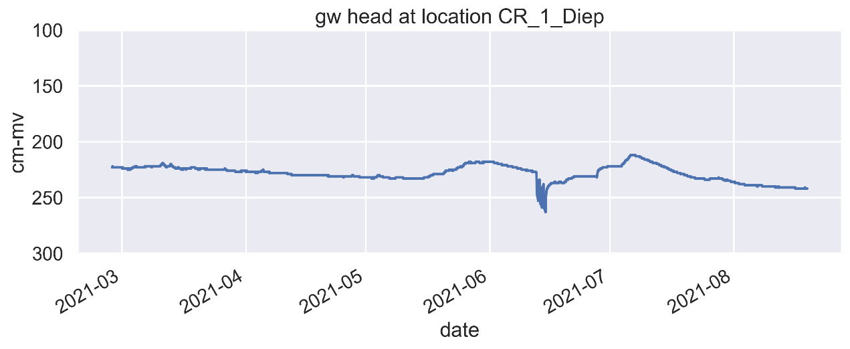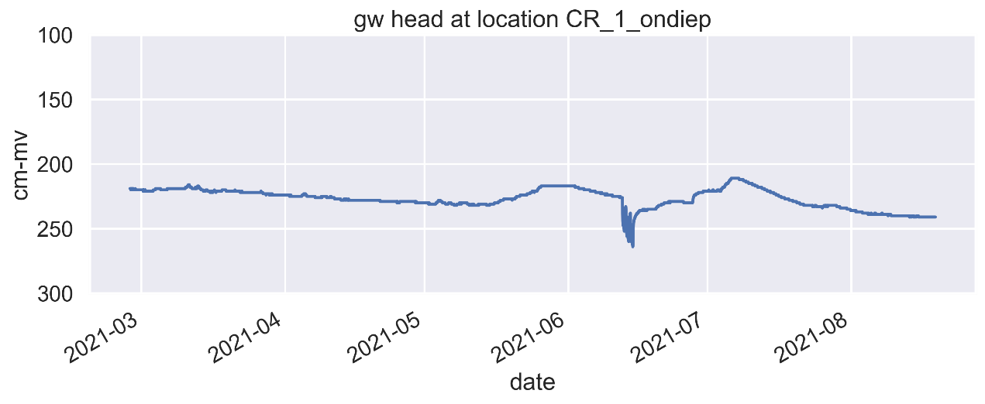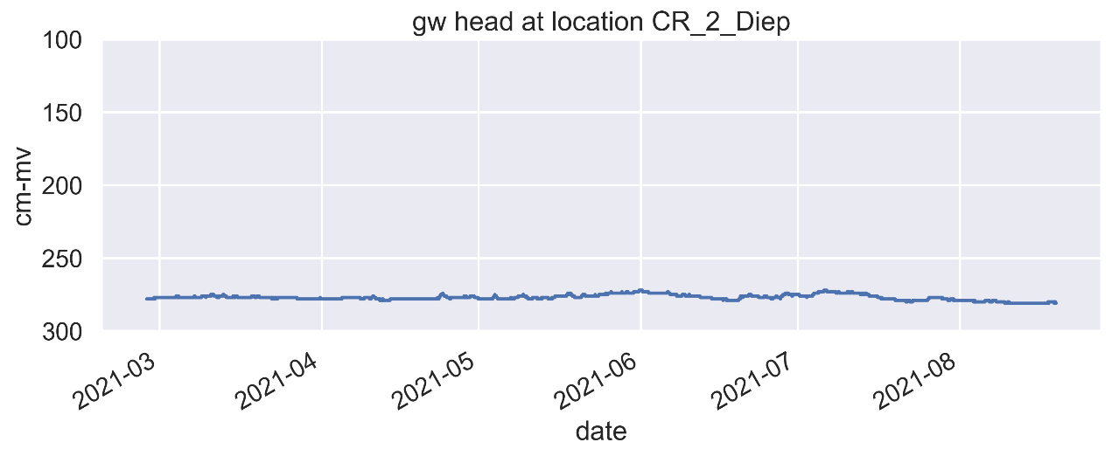
Figure 6 Groundwater heads for the Locations at Cruijningen.

Figure 7 shows that the groundwater heads at Dieleman are somewhere between 140 and 250 centimeters below surface level. The groundwater heads for the deep and shallow system are the same which gives a good indication that there are no confining layers and that there is no seepage flux between the deep and shallow system.

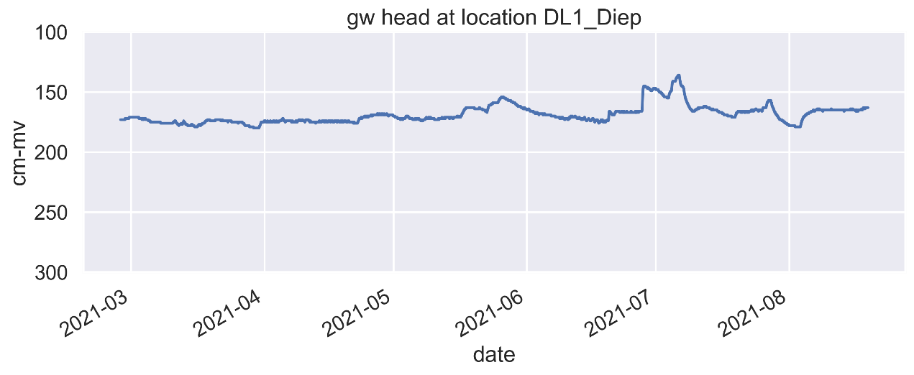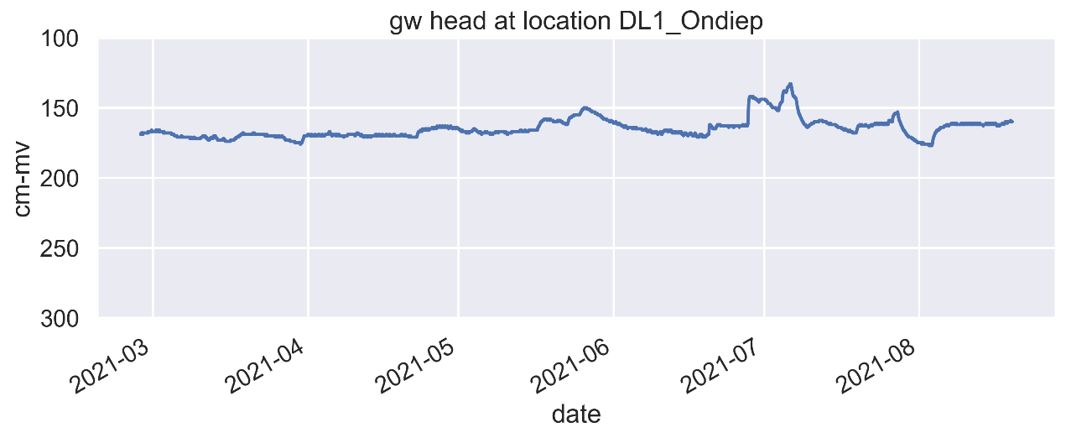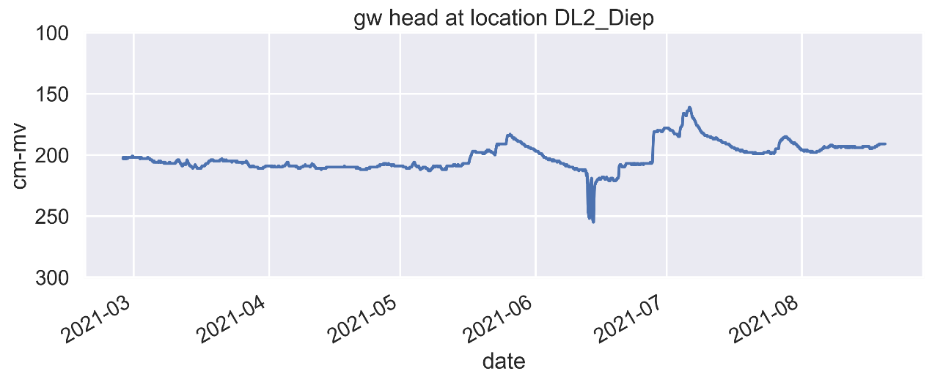
Figure 7 Groundwater heads for the locations at Dieleman

The rapid decrease of the groundwater levels in June could be the result of the extraction of groundwater with deep drains.

Chloride distribution

The chloride distribution at each deep monitoring well was determined by lowering a SLIMFLEX probe in the well. The EM-SLIMFLEX emission spool generates an electromagnetic field that is shaped such that the apparent soil resistivity is measured outside the borehole only. The signal is not disturbed by the water quality inside the borehole or piezometer. The electrical conductivity can be converted to chloride concentration using the formula of de Louw (2013).

SLIMFLEX Cruijningen

The fresh-salt interface is present at ca. 400 mS/m, which is equivalent to a chloride concentration ca. 1000 mg/L chloride. As expected from the FRESHEM dataset, the fresh salt interface at Cruijningen1 lies deeper than the interface at Cruijningen2. The depth of the fresh water lens according to the FRESHEM dataset and the SLIMFLEX measurements for Cruijningen is shown in Table 1.

Table 2 Fresh-salt interface according to FRESHEM and according to the SLIMFLEX measurements
Name | X | Y | Depth  (m-mv) | Filter length (m) | Depth lens FRESHEM  (1000 mg/L) m-mv) | Depth lens SLIMFLEX (400mS/m)  (m-mv)
Cruijningen_1_deep | 39215 | 369580 | 25 | 1 | 18 | 22
Cruijningen_2_deep | 39450 | 369600 | 15 | 1 | 9 | 10

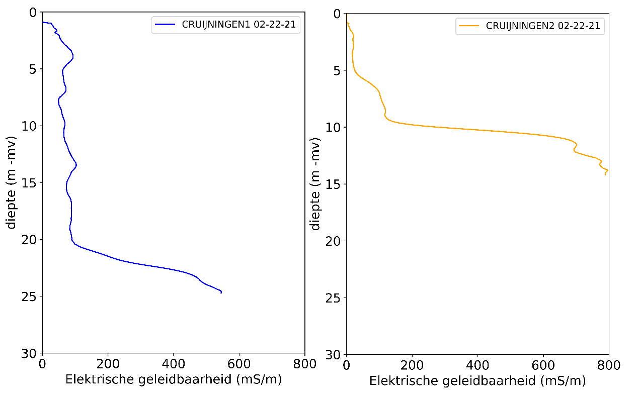
Figure 8 Slimflex measurements at locations Cruijningen. The thickness of the freshwater lens at Cruijningen1 is ca. 22 meters. The thickness of the freshwater lens at Cruijningen1 is ca. 10 m – mv.

SLIMFLEX Dieleman

The SLIMFLEX measurements (Figure 9 & Table 3) show that the freshwater lens in both locations at Dieleman is actually ca. 3 meters thicker than the FRESHEM dataset estimate. The measurements at “Dieleman1” show an inversion in the electrical conductivity (the chloride concentration decreases around 15 meter and then rises again). This means that the water quality in the lens varies (but is still fresh, below 1000 mg/L).

Table 3 Fresh-salt interface according to FRESHEM and according to the SLIMFLEX measurements
Name | X | Y | Depth  (m-mv) | Filter length (m) | Depth lens FRESHEM  (1000 mg/L) m-mv) | Depth lens SLIMFLEX (400mS/m)  (m-mv)
Dieleman_1_deep | 39135 | 367470 | 25 | 1 | 16.5 | 20
Dieleman_2_deep | 39565 | 367580 | 25 | 1 | 17 | 20

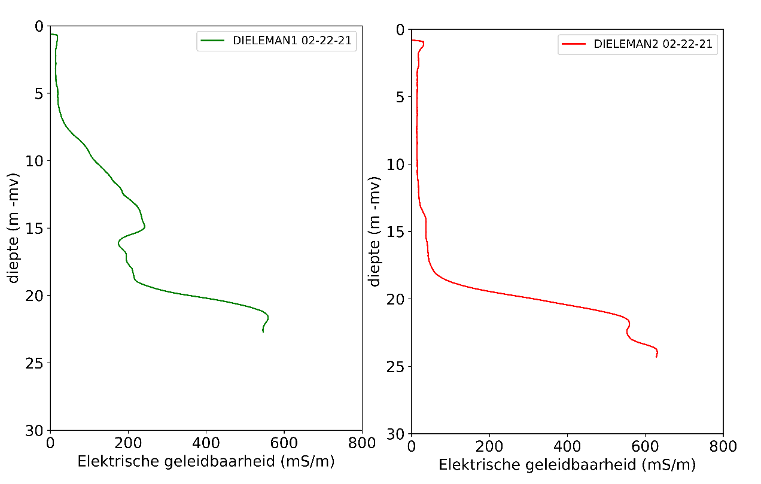
Figure 9 Slimflex measurements at locations Dieleman. The thickness of the freshwater lens at Dieleman1 ca. 20 m – mv. The thickness of the freshwater lens at Dieleman2 ca. 20 m – mv.

Final location

The memo in phase 1 concluded that, based on the groundwater model, national and regional datasets, a CRI system can be successfully installed in both locations for Cruijningen and Dieleman. The field measurements support that claim:
- The area is a natural infiltration area (so no seepage)
- There is enough space to increase the groundwater head (But less space at Dieleman.
- The Fresh water lens is thick. (But the lens at Cruijningen 2 is significantly smaller)
- The subsurface consist of sand (But at Dieleman the subsurface has a significant amount of organic material.

Based on the above conclusions, the most favorable location is Cruijningen1. Cruijningen 1 is also close to a good source of fresh water (direct connection to the Evides basin) and deepdrains have been installed late 2020 (Figure 10).

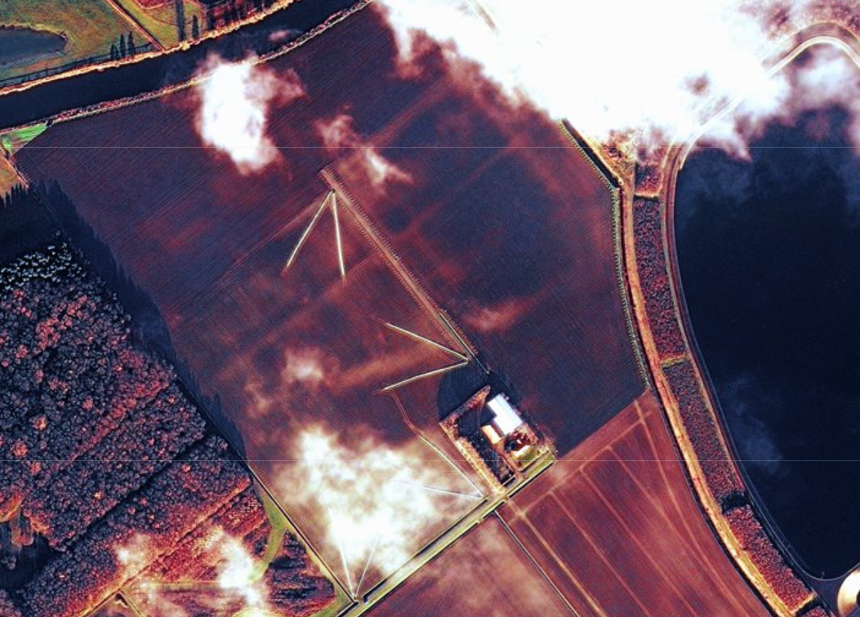
Figure 10 Arial photo of the location at Cruijningen in December 2020. The position of the deepdrains is visible with white (stirred soil) straight lines.

Design CRI pilot

Area

The area for the final location of the CRI pilot is shown in blue in Figure 11. The pilot covers an area of 3.5 hectares. The area was chosen based on the physical aspects, the position close to the connection with the fresh water basin and the position of the deepdrains.

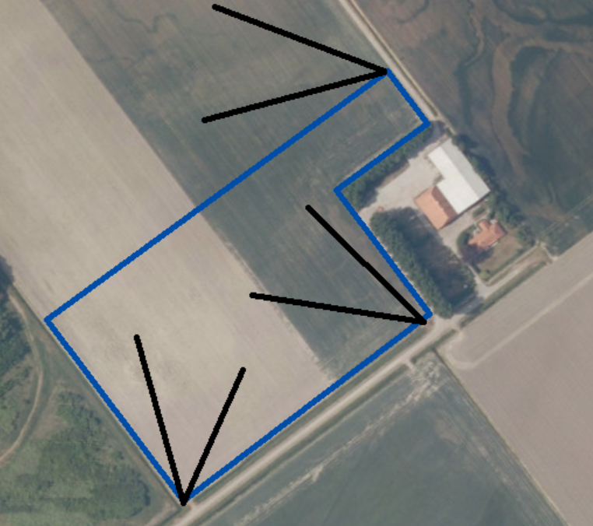
Figure 11 CRI pilot Area (Blue) and the locations of deep drains neat the pilot (black)

Infiltration

A Creek Ridge Infiltration system infiltrates water when abundant (winter or in our case a constant fresh water source) via controlled drainage. The advantage over conventional/passive drainage is that the groundwater level can be controlled by draining and infiltrating water to a desired level.
Controlled drainage has not been installed thus far but will be installed after the summer in 2021.

The controlled drainage will be used to infiltrate water at a constant rate from October up until Mach.

Previous CRI studies (Go-Fresh) showed that an infiltration rate of 1.66 mm/day is feasible. The infiltration rate of the Dow CRI pilot will also be 1.66 mm/day. This means that 55m³/day will be infiltrated over an area of 3.5 hectares. The total amount of infiltrated water is 10.000 m³ in 182 days. The amount of infiltrated water will be monitored with a water meter.

Extraction

To be determined..
Cruijningen will be able to use his deepdrains as he likes. The amount of water that Cruijningen uses will be monitored.
We aim to extract water with half of the infiltration rate ca. 0.8 mm/day.

The aim of the pilot is to show that water can be stored in winter and used in summer in a sustainable way. Cruijningen should therefore be able to extract the amount water that is permitted by the water board without reducing the fresh water lens.

We expect that the CRI system can store more water than Cruijningen needs and increase the fresh water lens. The surplus of stored water can then be used by other users such as Dow.

References
De Louw, P.G.B. 2013. Saline seepage in deltaic areas. Preferential groundwater discharge through boils and interactions between thin rainwater lenses and upward saline seepage. PhD thesis, Vrije Universiteit Amsterdam, ISBN/EAN 9789461085429.

